What makes an AI system an Agent?

In simple terms, an **AI agent** is a system designed to perceive its environment and take actions to achieve a specific goal. It's an evolution from a standard Large Language Model (LLM), enhanced with the abilities to plan, use tools, and interact with its surroundings. Think of an Agentic AI as a smart assistant that learns on the job. It follows a simple, five-step loop to get things done (see Fig.1):

1. **Get the Mission:** You give it a goal, like "organize my schedule."
2. **Scan the Scene:** It gathers all the necessary information—reading emails, checking calendars, and accessing contacts—to understand what's happening.
3. **Think It Through:** It devises a plan of action by considering the optimal approach to achieve the goal.
4. **Take Action:** It executes the plan by sending invitations, scheduling meetings, and updating your calendar.
5. **Learn and Get Better:** It observes successful outcomes and adapts accordingly. For example, if a meeting is rescheduled, the system learns from this event to enhance its future performance.

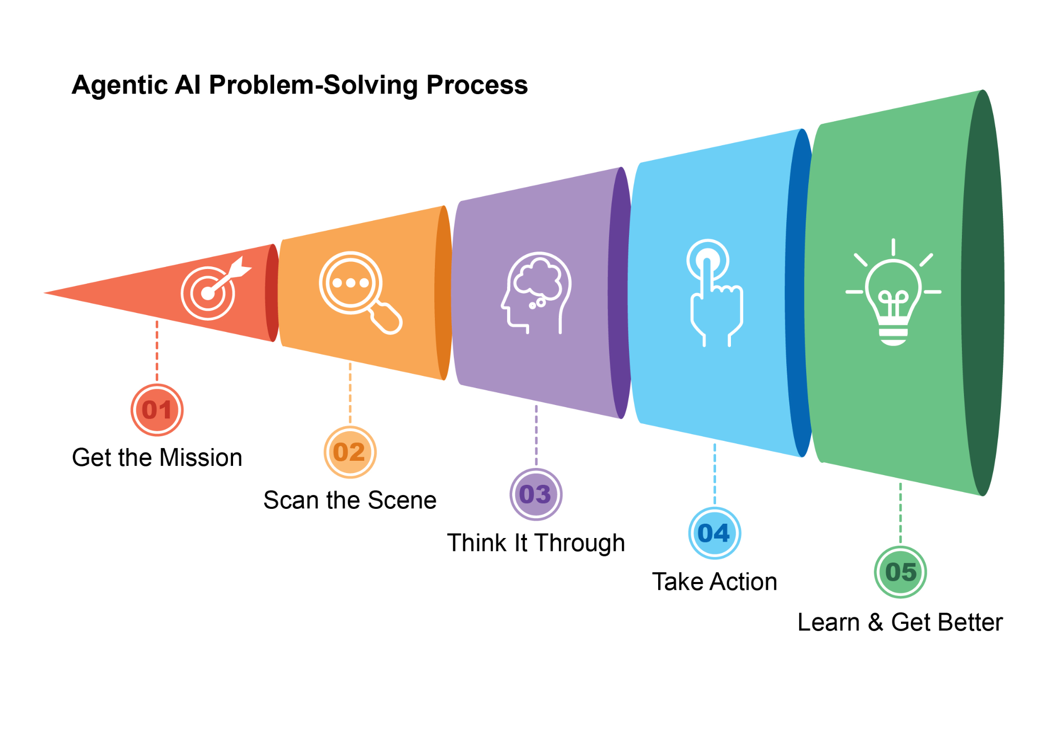

Fig.1: Agentic AI functions as an intelligent assistant, continuously learning through experience. It operates via a straightforward five-step loop to accomplish tasks.

Agents are becoming increasingly popular at a stunning pace. According to recent studies, a majority of large IT companies are actively using these agents, and a fifth of them just started within the past year. The financial markets are also taking notice. By the end of 2024, AI agent startups had raised more than $2 billion, and the market was valued at $5.2 billion. It's expected to explode to nearly $200 billion in value by 2034. In short, all signs point to AI agents playing a massive role in our future economy.

In just two years, the AI paradigm has shifted dramatically, moving from simple automation to sophisticated, autonomous systems (see Fig. 2). Initially, workflows relied on basic prompts and triggers to process data with LLMs. This evolved with Retrieval-Augmented Generation (RAG), which enhanced reliability by grounding models on factual information. We then saw the development of individual AI Agents capable of using various tools. Today, we are entering the era of Agentic AI, where a team of specialized agents works in concert to achieve complex goals, marking a significant leap in AI's collaborative power.

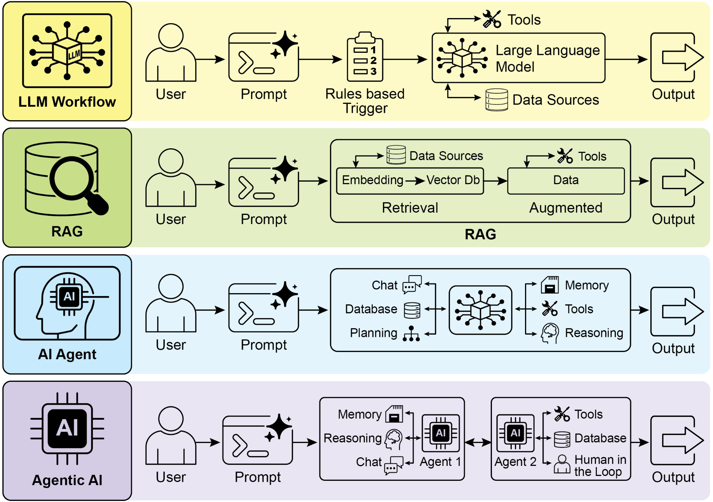

Fig 2.: Transitioning from LLMs to RAG, then to Agentic RAG, and finally to Agentic AI.

The intent of this book is to discuss the design patterns of how specialized agents can work in concert and collaborate to achieve complex goals, and you will see one paradigm of collaboration and interaction in each chapter.

Before doing that, let's examine examples that span the range of agent complexity (see Fig. 3).

### Level 0: The Core Reasoning Engine

While an LLM is not an agent in itself, it can serve as the reasoning core of a basic agentic system. In a 'Level 0' configuration, the LLM operates without tools, memory, or environment interaction, responding solely based on its pretrained knowledge. Its strength lies in leveraging its extensive training data to explain established concepts. The trade-off for this powerful internal reasoning is a complete lack of current-event awareness. For instance, it would be unable to name the 2025 Oscar winner for "Best Picture" if that information is outside its pre-trained knowledge.

### Level 1: The Connected Problem-Solver

At this level, the LLM becomes a functional agent by connecting to and utilizing external tools. Its problem-solving is no longer limited to its pre-trained knowledge. Instead, it can execute a sequence of actions to gather and process information from sources like the internet (via search) or databases (via Retrieval Augmented Generation, or RAG). For detailed information, refer to Chapter 14.

For instance, to find new TV shows, the agent recognizes the need for current information, uses a search tool to find it, and then synthesizes the results. Crucially, it can also use specialized tools for higher accuracy, such as calling a financial API to get the live stock price for AAPL. This ability to interact with the outside world across multiple steps is the core capability of a Level 1 agent.

### Level 2: The Strategic Problem-Solver

At this level, an agent's capabilities expand significantly, encompassing strategic planning, proactive assistance, and self-improvement, with prompt engineering and context engineering as core enabling skills.

First, the agent moves beyond single-tool use to tackle complex, multi-part problems through strategic problem-solving. As it executes a sequence of actions, it actively performs context engineering: the strategic process of selecting, packaging, and managing the most relevant information for each step. For example, to find a coffee shop between two locations, it first uses a mapping tool. It then engineers this output, curating a short, focused context—perhaps just a list of street names—to feed into a local search tool, preventing cognitive overload and ensuring the second step is efficient and accurate. To achieve maximum accuracy from an AI, it must be given a short, focused, and powerful context. Context engineering is the discipline that accomplishes this by strategically selecting, packaging, and managing the most critical information from all available sources. It effectively curates the model's limited attention to prevent overload and ensure high-quality, efficient performance on any given task. For detailed information, refer to the Appendix A.

This level leads to proactive and continuous operation. A travel assistant linked to your email demonstrates this by engineering the context from a verbose flight confirmation email; it selects only the key details (flight numbers, dates, locations) to package for subsequent tool calls to your calendar and a weather API.

In specialized fields like software engineering, the agent manages an entire workflow by applying this discipline. When assigned a bug report, it reads the report and accesses the codebase, then strategically engineers these large sources of information into a potent, focused context that allows it to efficiently write, test, and submit the correct code patch.

Finally, the agent achieves self-improvement by refining its own context engineering processes. When it asks for feedback on how a prompt could have been improved, it is learning how to better curate its initial inputs. This allows it to automatically improve how it packages information for future tasks, creating a powerful, automated feedback loop that increases its accuracy and efficiency over time. For detailed information, refer to Chapter 17.

### 

Fig. 3: Various instances demonstrating the spectrum of agent complexity.

### Level 3: The Rise of Collaborative Multi-Agent Systems

At Level 3, we see a significant paradigm shift in AI development, moving away from the pursuit of a single, all-powerful super-agent and towards the rise of sophisticated, collaborative multi-agent systems. In essence, this approach recognizes that complex challenges are often best solved not by a single generalist, but by a team of specialists working in concert. This model directly mirrors the structure of a human organization, where different departments are assigned specific roles and collaborate to tackle multi-faceted objectives. The collective strength of such a system lies in this division of labor and the synergy created through coordinated effort. For detailed information, refer to Chapter 7.

To bring this concept to life, consider the intricate workflow of launching a new product. Rather than one agent attempting to handle every aspect, a "Project Manager" agent could serve as the central coordinator. This manager would orchestrate the entire process by delegating tasks to other specialized agents: a "Market Research" agent to gather consumer data, a "Product Design" agent to develop concepts, and a "Marketing" agent to craft promotional materials. The key to their success would be the seamless communication and information sharing between them, ensuring all individual efforts align to achieve the collective goal.

While this vision of autonomous, team-based automation is already being developed, it's important to acknowledge the current hurdles. The effectiveness of such multi-agent systems is presently constrained by the reasoning limitations of LLMs they are using. Furthermore, their ability to genuinely learn from one another and improve as a cohesive unit is still in its early stages. Overcoming these technological bottlenecks is the critical next step, and doing so will unlock the profound promise of this level: the ability to automate entire business workflows from start to finish.

### The Future of Agents: Top 5 Hypotheses

AI agent development is progressing at an unprecedented pace across domains such as software automation, scientific research, and customer service among others. While current systems are impressive, they are just the beginning. The next wave of innovation will likely focus on making agents more reliable, collaborative, and deeply integrated into our lives. Here are five leading hypotheses for what's next (see Fig. 4).

### Hypothesis 1: The Emergence of the Generalist Agent

The first hypothesis is that AI agents will evolve from narrow specialists into true generalists capable of managing complex, ambiguous, and long-term goals with high reliability. For instance, you could give an agent a simple prompt like, "Plan my company's offsite retreat for 30 people in Lisbon next quarter." The agent would then manage the entire project for weeks, handling everything from budget approvals and flight negotiations to venue selection and creating a detailed itinerary from employee feedback, all while providing regular updates. Achieving this level of autonomy will require fundamental breakthroughs in AI reasoning, memory, and near-perfect reliability. An alternative, yet not mutually exclusive, approach is the rise of Small Language Models (SLMs). This "Lego-like" concept involves composing systems from small, specialized expert agents rather than scaling up a single monolithic model. This method promises systems that are cheaper, faster to debug, and easier to deploy. Ultimately, the development of large generalist models and the composition of smaller specialized ones are both plausible paths forward, and they could even complement each other.

### Hypothesis 2: Deep Personalization and Proactive Goal Discovery

The second hypothesis posits that agents will become deeply personalised and proactive partners. We are witnessing the emergence of a new class of agent: the proactive partner. By learning from your unique patterns and goals, these systems are beginning to shift from just following orders to anticipating your needs. AI systems operate as agents when they move beyond simply responding to chats or instructions. They initiate and execute tasks on behalf of the user, actively collaborating in the process. This moves beyond simple task execution into the realm of proactive goal discovery.

For instance, if you're exploring sustainable energy, the agent might identify your latent goal and proactively support it by suggesting courses or summarizing research. While these systems are still developing, their trajectory is clear. They will become increasingly proactive, learning to take initiative on your behalf when highly confident that the action will be helpful. Ultimately, the agent becomes an indispensable ally, helping you discover and achieve ambitions you have yet to fully articulate.

### 

Fig. 4: Five hypotheses about the future of agents

### Hypothesis 3: Embodiment and Physical World Interaction

This hypothesis foresees agents breaking free from their purely digital confines to operate in the physical world. By integrating agentic AI with robotics, we will see the rise of "embodied agents." Instead of just booking a handyman, you might ask your home agent to fix a leaky tap. The agent would use its vision sensors to perceive the problem, access a library of plumbing knowledge to formulate a plan, and then control its robotic manipulators with precision to perform the repair. This would represent a monumental step, bridging the gap between digital intelligence and physical action, and transforming everything from manufacturing and logistics to elder care and home maintenance.

### Hypothesis 4: The Agent-Driven Economy

The fourth hypothesis is that highly autonomous agents will become active participants in the economy, creating new markets and business models. We could see agents acting as independent economic entities, tasked with maximising a specific outcome, such as profit. An entrepreneur could launch an agent to run an entire e-commerce business. The agent would identify trending products by analysing social media, generate marketing copy and visuals, manage supply chain logistics by interacting with other automated systems, and dynamically adjust pricing based on real-time demand. This shift would create a new, hyper-efficient "agent economy" operating at a speed and scale impossible for humans to manage directly.

### Hypothesis 5: The Goal-Driven, Metamorphic Multi-Agent System

This hypothesis posits the emergence of intelligent systems that operate not from explicit programming, but from a declared goal. The user simply states the desired outcome, and the system autonomously figures out how to achieve it. This marks a fundamental shift towards metamorphic multi-agent systems capable of true self-improvement at both the individual and collective levels.

This system would be a dynamic entity, not a single agent. It would have the ability to analyze its own performance and modify the topology of its multi-agent workforce, creating, duplicating, or removing agents as needed to form the most effective team for the task at hand. This evolution happens at multiple levels:

* Architectural Modification: At the deepest level, individual agents can rewrite their own source code and re-architect their internal structures for higher efficiency, as in the original hypothesis.
* Instructional Modification: At a higher level, the system continuously performs automatic prompt engineering and context engineering. It refines the instructions and information given to each agent, ensuring they are operating with optimal guidance without any human intervention.

For instance, an entrepreneur would simply declare the intent: "Launch a successful e-commerce business selling artisanal coffee." The system, without further programming, would spring into action. It might initially spawn a "Market Research" agent and a "Branding" agent. Based on the initial findings, it could decide to remove the branding agent and spawn three new specialized agents: a "Logo Design" agent, a "Webstore Platform" agent, and a "Supply Chain" agent. It would constantly tune their internal prompts for better performance. If the webstore agent becomes a bottleneck, the system might duplicate it into three parallel agents to work on different parts of the site, effectively re-architecting its own structure on the fly to best achieve the declared goal.

# Conclusion

In essence, an AI agent represents a significant leap from traditional models, functioning as an autonomous system that perceives, plans, and acts to achieve specific goals. The evolution of this technology is advancing from single, tool-using agents to complex, collaborative multi-agent systems that tackle multifaceted objectives. Future hypotheses predict the emergence of generalist, personalized, and even physically embodied agents that will become active participants in the economy. This ongoing development signals a major paradigm shift towards self-improving, goal-driven systems poised to automate entire workflows and fundamentally redefine our relationship with technology.

# References

1. Cloudera, Inc. (April 2025), 96% of enterprises are increasing their use of AI agents.<https://www.cloudera.com/about/news-and-blogs/press-releases/2025-04-16-96-percent-of-enterprises-are-expanding-use-of-ai-agents-according-to-latest-data-from-cloudera.html>
2. Autonomous generative AI agents: <https://www.deloitte.com/us/en/insights/industry/technology/technology-media-and-telecom-predictions/2025/autonomous-generative-ai-agents-still-under-development.html>
3. Market.us. Global Agentic AI Market Size, Trends and Forecast 2025–2034. <https://market.us/report/agentic-ai-market/>